1. 1. Question

This question requires that you evaluate the below  text to determine if it is correct.  
When you enable external access by using the Microsoft 365 admin portal, data is available to anonymous users.  
Review the above text. If above statement is correct, select “No change is needed”. If the statement is incorrect, select the answer choice that makes the statement correct.

* +  the Everyone group is applied to all shares with full control
  +  No change needed
  +  you must configure Active Directory Federation Services (AD FS)
  +  users can send sharing invitations for specific content

Unattempted

External sharing overview  
The external sharing features of SharePoint Online let users in your organization share content with people outside the organization (such as partners, vendors, clients, or customers). You can also use external sharing to share between licensed users on multiple Office 365 subscriptions if your organization has more than one subscription. Planning for external sharing should be included as part of your overall permissions planning for SharePoint Online.  
How the external sharing settings work  
SharePoint Online has external sharing settings at both the organization level and the site level (previously called the “site collection” level). To allow external sharing on any site, you must allow it at the organization level. You can then restrict external sharing for other sites. If a site’s external sharing option and the organization-level sharing option don’t match, the most restrictive value will always be applied.  
Whichever option you choose at the organization or site level, the more restrictive functionality is still available. For example, if you choose to allow unauthenticated sharing using “Anyone” links (previously called “shareable” links or “anonymous access” links), users can still share with guests, who sign in, and with internal users.  
Security and privacy  
If you have confidential information that should never be shared externally, we recommend storing the information in a site that has external sharing turned off. Create additional sites as needed to use for external sharing. This helps you to manage security risk by preventing external access to sensitive information.

1. 2. Question

This question requires that you evaluate the underlined text to determine if it is correct.  
A company needs to protect documents and emails by automatically applying classifications and labels. You must minimize costs.  
You should implement Information Rights Management.  
Review the above text. If it makes the statement correct, select No change is needed. If the statement is incorrect, select the answer choice that makes the statement correct.

* +  No change needed
  +  Azure Information Protection Premium P2
  +  Azure Information Protection Premium P1
  +  Microsoft 365 E3

Unattempted

<https://azure.microsoft.com/en-us/pricing/details/information-protection/>

1. 3. Question

You are a Microsoft 365 administrator for a company. Employees use Microsoft Office 365  ProPlus to create documents. You need to implement document classification and protection by using Microsoft Azure Information Protection. Which two actions should you perform? Each correct answer presents part of the solution.

* +  Enable the default Azure information Protection Policy
  +  Install the Azure Information Protection client
  +  Add an Azure subscription to your Microsoft 365 tenant
  +  Create a custom Azure Information Protection policy with the confidential label
  +  Install the Rights Management Service client

Unattempted

1. 4. Question

You are a Microsoft 365 administrator for a company. Microsoft plans to release a new feature for Microsoft Excel. You need to ensure that the feature becomes available for employees to install as soon as possible. To which release channel should you subscribe?

* +  Targeted release
  +  Office 365 team release
  +  Standard release
  +  Microsoft release

Unattempted

Any new release is first tested and validated by the feature team, then by the entire Office 365 feature team, followed by all of Microsoft. After internal testing and validation, the next step is a Targeted release (formerly known as First release) to customers who opt in. At each release ring, Microsoft collects feedback and further validates quality by monitoring key usage metrics. This series of progressive validation is in place to make sure the worldwide-release is as robust as possible. The releases are pictured in the following figure.

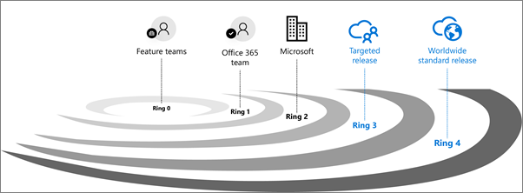

Standard release  
This is the default option where you and your users receive the latest updates when they’re released broadly to all customers.  
A good practice is to leave the majority of users in Standard release and IT Pros and power users in Targeted release to evaluate new features and prepare teams to support business users and executives.

Targeted release  
With this option, you and your users can be the first to see the latest updates and help shape the product by providing early feedback. You can choose to have individuals or the entire organization receive updates early.

1. 5. Question

You are a Microsoft 365 administrator for a company. Several users report that they receive emails which have a PDF attachment. The PDF attachment launches malicious code. You need to remove the message from inboxes and disable the PDF threat if an affected document is opened. Which feature should you implement?

* +  DKIM signed messages with mail flow rules
  +  Microsoft Exchange Admin Center block lists
  +  Sender Policy Framework
  +  Advanced Threat Protection anti-phishing
  +  zero-hour auto purge

Unattempted

1. 6. Question

You are a Microsoft 365 administrator for a company. The company implements federated authentication and Azure AD Connect. For the following statements, select Yes if the statement is true. Otherwise, select No.  
Users have the same passwords in the cloud and on-premises.

* +  YES
  +  NO

Unattempted

1. 7. Question

You are a Microsoft 365 administrator for a company. The company implements federated authentication and Azure AD Connect. For the following statements, select Yes if the statement is true. Otherwise, select No.  
Users sign in again to access Microsoft 365.

* +  Yes
  +  No

Unattempted

1. 8. Question

You are a Microsoft 365 administrator for a company. The company implements federated authentication and Azure AD Connect. For the following statements, select Yes if the statement is true. Otherwise, select No.  
You can configure federated authentication to require a smart card.

* +  No
  +  Yes

Unattempted

1. 9. Question

You are the Microsoft 365 administrator for a company. A user experiences an issue with SharePoint Online. You need to resolve the issue. Which two options can you use? Each correct answer presents a complete solution (Choose two)

* +  Go to the SharePoint admin and create a support request
  +  Contact Microsoft technical support by telephone
  +  Create a new service request from the Microsoft 365 admin center.
  +  Create a service request from the SharePoint portal

Unattempted

<https://docs.microsoft.com/en-us/archive/blogs/praveenkumar/how-to-create-service-requests-to-contact-office-365-support>

1. 10. Question

You are the Microsoft 365 administrator for a company. All staff must use Microsoft Outlook to access corporate email. When users access Outlook on mobile devices, they must use a PIN to open the application. You need to implement a Microsoft Intune Policy to enforce the security requirements. Which policy should you use?

* +  device configuration
  +  app configuration
  +  app protection
  +  device compliance

Unattempted

1. 11. Question

You are the Microsoft 365 administrator for a company. An employee requests personal data under General Data Protection Regulation (GDPR) guidelines. You need to retrieve data fro the employee. What should you do?

* +  Create a data subject request case.
  +  Create a data-loss prevention policy
  +  Create a retention policy.
  +  Create a GDPR assessment

Unattempted

1. 12. Question

You are the Microsoft 365 administrator for a company. The company plans to upgrade client operating systems to Windows 10. You need to explain the concepts of Windows as a Service (WaaS) to the management team. Match the term for the following definition:  
Early builds that are released to the public during the feature-development phase.

* +  Servicing Channels
  +  Windows Insider Previews
  +  Deployment rings

Unattempted

For Windows as a service, maintenance is ongoing and iterative. Deploying previous versions of Windows required organizations to build sets of users to roll out the changes in phases. Typically, these users ranged (in order) from the most adaptable and least risky to the least adaptable or riskiest. With Windows 10, a similar methodology exists, but construction of the groups is a little different.  
Deployment rings in Windows 10 are similar to the deployment groups most organizations constructed for previous major revision upgrades. They are simply a method by which to separate machines into a deployment timeline. With Windows 10, you construct deployment rings a bit differently in each servicing tool, but the concepts remain the same. Each deployment ring should reduce the risk of issues derived from the deployment of the feature updates by gradually deploying the update to entire departments.  
Defining deployment rings is generally a one-time event (or at least infrequent), but IT should revisit these groups to ensure that the sequencing is still correct. Also, there are times in which client computers could move between different deployment rings when necessary.  
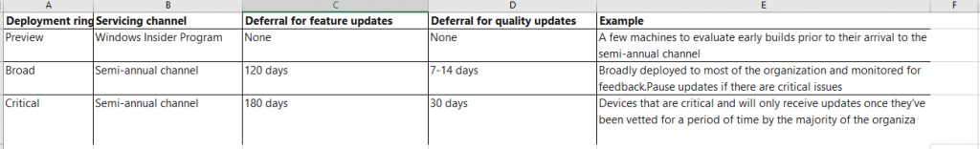

1. 13. Question

You are the Microsoft 365 administrator for a company. The company plans to upgrade client operating systems to Windows 10. You need to explain the concepts of Windows as a Service (WaaS) to the management team.  
Match the term to its definition:  
A method of gradually deploying Windows 10 features by using multiple sets of targeted devices.

* +  Office 365
  +  Deployment rings
  +  Windows Insider previews
  +  Servicing Channels

Unattempted

Microsoft’s Definition Of Deployment Rings  
Deployment rings in Windows 10 are similar to the deployment groups most organizations constructed for previous major revision upgrades. They are simply a method by which to separate machines into a deployment timeline. With Windows 10, you construct deployment rings a bit differently in each servicing tool, but the concepts remain the same.  
Each deployment ring should reduce the risk of issues derived from the deployment of the feature updates by gradually deploying the update to entire departments. As previously mentioned, consider including a portion of each department’s employees in several deployment rings.

1. 14. Question

You are the Microsoft 365 administrator for a company. The company plans to upgrade client operating systems to Windows 10. You need to explain the concepts of Windows as a Service (WaaS) to the management team.  
Which of the following term matches to the below definition?  
A method for controlling the frequency at which organizations deploy Windows 10 features.

* +  Windows Insider previews
  +  Deployment Rings
  +  Servicing Channels

Unattempted

<https://docs.microsoft.com/en-us/windows/deployment/update/waas-overview>

1. 15. Question

You are the Microsoft 365 administrator for a company. The company runs SharePoint Server and Exchange Server in an on-premises datacenter. The site collection for the finance department is currently encrypted using third-party software. You need to move as many services to Microsoft 365 as possible.

* +  Leave SharePoint data and mailboxes for finance department users on premises. Migrate all other Sharepoint data and Exchange mailboxes to Microsoft 365.
  +  Leave SharePoint data for finance department users on-premises. Migrate all other SharePoint data and Exchange mailboxes to Microsoft 365.
  +  Leave mailboxes for finance department users on-premises. Migrate all other SharePoint data and Exchange mailboxes to Microsoft 365.
  +  Migrate all SharePoint data and Exchange mailboxes to Microsoft 365

Unattempted

1. 16. Question

You are the Microsoft 365 administrator for a company. Users in the IT department must receive new Office 365 preview features before the features are deployed to other users in the company. You need to ensure only the users in the IT department receive preview features .  
Which two actions should you perform ? Each correct answer represents part of the solution. (Choose two)

* +  In the organizational profile, set the update preference to Targeted release for selected users.
  +  Instruct users to uninstall Office ProPlus and then reinstall the software
  +  Instruct users to navigate to https://insider.office.com and sign up for Office Insider
  +  In the organizational profile, set the update preference to Standard release
  +  Instruct users to  update Office ProPlus

Unattempted

1. 17. Question

You are the Microsoft 365 administrator for a company. Which Microsoft 365 components should employees use for the following task:  
1) Hold a voice and video conversation with other employees.

* +  Microsoft Exchange Online
  +  Microsoft Teams
  +  Windows 10 Enterprise
  +  Microsoft Enterprise Mobility +Security

Unattempted

Microsoft Teams on Office 365 is a collaborative workspace that facilitates a modern way of working. It is especially helpful for remote teams, although it offers great benefits to in-house employees as well. Microsoft Teams can help boost team productivity, increase collaboration across departments, and help your company complete tasks in a quick, efficient manner.  
For more information: https://products.office.com/en-us/microsoft-teams/group-chat-software  
<https://www.microsoft.com/en-us/microsoft-365/enterprise-mobility-security?rtc=1>

1. 18. Question

You are the Microsoft 365 administrator for a company. Which Microsoft 365 components should employees use for the following:  
1) Author a document at the same time as someone else and use document versioning.

* +  Microsoft Teams
  +  Microsoft Exchange Online
  +  Microsoft SharePoint Online
  +  Windows 10 Enterprise

Unattempted

Benefits of SharePoint Online:  
1) It’s cloud-based  
2) Seamless integration with Microsoft Office : As it is a product of Microsoft, it’s designed to work effortlessly with Microsoft Office Suite.  
3) Document collaboration: Colleagues can work collaboratively on the same document at the same time.You can see a live feed of who is in the document with you and refresh it to see the changes they’ve made.  
4) You can roll back to earlier versions: SharePoint Online automatically keeps a handy version history of documents. Not only is this useful for rolling back to an earlier version, should you need to, you can also see who has contributed to the document over time.

1. 19. Question

You are the Microsoft 365 administrator for a company. Which Microsoft 365 components should employees use for the following:  
1) Send an email to a distribution list  
2) View a personal calendar

* +  Microsoft Teams
  +  Microsoft SharePoint Online
  +  Microsoft Enterprise Mobility + Security
  +  Microsoft Exchange Online

Unattempted

Microsoft SharePoint Online is a collection of cloud- and web-based technologies that makes it easy to store, share and manage digital information within an organization.  
Microsoft Exchange Online is a hosted messaging solution that delivers the capabilities of Microsoft Exchange Server as a cloud-based service. It gives users access to email, calendar, contacts, and tasks from PCs, the web, and mobile devices.  
Microsoft Teams is a communication and collaboration platform that combines persistent chat capabilities, video conferencing, file storage, and integration with many other Office 365 apps.  
Microsoft Enterprise Mobility +Security is an intelligent mobility management and security platform. It helps protect and secure your organization and empowers your employees to work in new and flexible ways.  
For more:  
<https://products.office.com/en-us/microsoft-teams/group-chat-software>  
<https://www.microsoft.com/en-us/microsoft-365/enterprise-mobility-security?rtc=1>

1. 20. Question

You are the Microsoft 365 administrator for a company. Which two admin roles can purchase more licenses? Each correct answer presents a complete solution.

* +  Service administrator
  +  User management administrator
  +  global administrator
  +  billing administrator

Unattempted

1. 21. Question

You are the Microsoft 365 administrator for a company. You install Microsoft Office 365 ProPlus on five devices. You deactivate device. Which task can you perform on the deactivated device?

* +  Set properties on a document
  +  Edit a document
  +  Start a new document from a template
  +  Create a document
  +  Print a document
  +  Leave a comment in a document

Unattempted

1. 22. Question

You are the Microsoft 365 administrator for a company. You install Microsoft office 365 ProPlus on five devices. You deactivate the Microsoft office 365 ProPlus license on one device. Which task can you perform on the deactivated device?

* +  Set properties on a document
  +  Create a document
  +  View a document
  +  Start a new document from a template
  +  Leave a comment in a document
  +  Co-author a document

Unattempted

1. 23. Question

You are the Microsoft 365 administrator for a company. You need to customize a usage report for Microsoft Yammer. Which two tools can you use? Each correct answer presents a complete solution.q

* +  Microsoft SQL Server Reporting Services
  +  Microsoft SQL Server Analysis Services
  +  Microsoft Visual Studio
  +  Microsoft Power BI Desktop
  +  Microsoft Power BI in a browser

Unattempted

Microsoft 365 usage analytics provides a dashboard in Power BI that offers insights into how users adopt and use Office 365. The dashboard is just a starting point to interact with the usage data. The reports can be customized for more personalized insights.  
You can also use the Power BI desktop to further customize your reports by connecting them to other data sources to gain richer insights about your business.  
Customizing the reports in Power BI Desktop  
For most customers modifying the reports and chart visuals in Power BI web will be sufficient. For some however, there may be a need to join this data with other data sources to gain richer insights contextual to their own business, in which case they can customize and build additional reports using Power BI Desktop.

1. 24. Question

You are the Microsoft 365 administrator for a company. You need to ensure that users receive a warning message if they select links in emails that might be unsafe. What should you do?

* +  Use Windows PowerShell to install the latest antimalware engine updates
  +  Use the Microsoft Exchange Admin Center to create a new antimalware policy.
  +  Enable Microsoft Office 365 Advanced Threat Protection
  +  Use the Microsoft Exchange Admin Center to configure a new spam-filter policy.

Unattempted

1. 25. Question

You are the Microsoft 365 administrator for a company. You need to track scheduled maintenance events in Microsoft 365 admin center. Where can you track these events?

* +  Reports
  +  Support
  +  Service Health
  +  Message Center

Unattempted

1. 26. Question

You are the Microsoft 365 administrator for a company. Your company plans to open a new office in the United Kingdom. You need to provide penetration test and security assessment reports for the new office. Where can you locate the required reports?

* +  Compliance Manager page of the Services Trust portal
  +  Regional Compliance page of the Services Trust portal
  +  Data Governance page of the security and Compliance portal
  +  Data Loss Prevention page of the Security and Compliance portal

Unattempted

1. 27. Question

You are the Microsoft 365 administrator for a company. Your company wants to learn about what happens if the availability terms of the Microsoft Office 365 services are not met. Where can you find this information?

* +  Service Level agreement
  +  Microsoft Services agreement
  +  Microsoft Cloud agreement
  +  Microsoft Products and Services agreement
  +  Microsoft Enterprise agreement

Unattempted

<https://docs.microsoft.com/en-us/office365/servicedescriptions/office-365-platform-service-description/service-level-agreement#microsoft-online-services-level-agreement>

1. 28. Question

You are the Microsoft 365 administrator for an organization. A group of employees and users outside the company must be able to collaborate on a project real time by using a whiteboard. In the Microsoft 365 admin portal, which office 365 product should you configure?

* +  Microsoft Teams
  +  Microsoft SharePoint Online
  +  Microsoft Office Delve
  +  Microsoft Yammer

Unattempted

Microsoft Whiteboard is a free-form, digital canvas where people, content, and ideas come together. Whiteboard integration in Microsoft Teams meetings is powered by the Whiteboard web app, which lets Teams meeting participants draw, sketch, and write together on a shared digital canvas.  
Users can share a whiteboard to make it available to all participants in a Teams meeting. That same whiteboard is simultaneously available in all the Whiteboard applications on Windows 10, iOS, and the web app.

1. 29. Question

You are the Microsoft office 365 administrator for a company. You need to determine which technologies should be used for following requirement?  
Users must be able to use incompatible applications on a Windows 10 device

* +  Azure AD application Proxy
  +  Windows Virtual Desktop
  +  Azure AD Connect
  +  Microsoft Intune

Unattempted

What is Windows Virtual Desktop?  
Windows Virtual Desktop is a comprehensive desktop and app virtualization service running in the cloud. It’s the only virtual desktop infrastructure (VDI) that delivers simplified management, multi-session Windows 10, optimizations for Office 365 ProPlus, and support for Remote Desktop Services (RDS) environments. Deploy and scale your Windows desktops and apps on Azure in minutes, and get built-in security and compliance features.

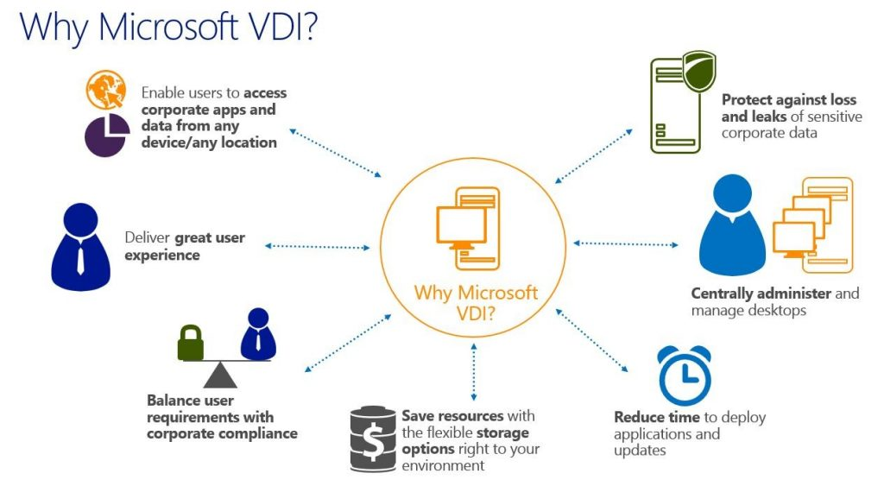

<https://azure.microsoft.com/en-us/services/virtual-desktop/>

1. 30. Question

You are the Microsoft Office 365 administrator for a company. You need to determine which technologies should be used for the following requirement:  
Cloud based applications must use the same credentials as on-premises applications.

* +  Azure AD Connect
  +  Azure AD Application proxy
  +  Windows Virtual Desktop
  +  Microsoft Intune

Unattempted

What is Azure AD Connect?  
Azure AD Connect is the Microsoft tool designed to meet and accomplish your hybrid identity goals. It provides the following features:  
Password hash synchronization – A sign-in method that synchronizes a hash of a users on-premises AD password with Azure AD.  
Pass-through authentication – A sign-in method that allows users to use the same password on-premises and in the cloud, but doesn’t require the additional infrastructure of a federated environment.  
Federation integration – Federation is an optional part of Azure AD Connect and can be used to configure a hybrid environment using an on-premises AD FS infrastructure. It also provides AD FS management capabilities such as certificate renewal and additional AD FS server deployments.  
Synchronization – Responsible for creating users, groups, and other objects. As well as, making sure identity information for your on-premises users and groups is matching the cloud. This synchronization also includes password hashes.  
Health Monitoring – Azure AD Connect Health can provide robust monitoring and provide a central location in the Azure portal to view this activity.

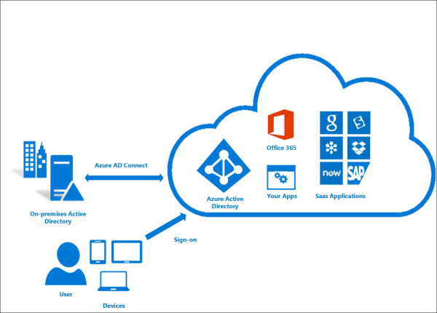

1. 31. Question

You are the Microsoft Office 365 administrator for a company. You need to determine which technologies should be used for the following requirement:  
Users must be prevented from copying company data from managed applications installed on unmanaged devices.

* +  Azure AD Connect
  +  Windows Virtual Desktop
  +  Microsoft Intune
  +  Azure AD Application Proxy

Unattempted

Microsoft Intune is an MDM and MAM provider for your devices:  
Microsoft Intune is a cloud-based service that focuses on mobile device management (MDM) and mobile application management (MAM). Intune is included in Microsoft’s Enterprise Mobility + Security (EMS) suite, and enables users to be productive while keeping your organization data protected.  
It integrates with other services, including Microsoft 365 and Azure Active Directory (Azure AD) to control who has access, and what they have access to, and Azure Information Protection for data protection. When you use it with Microsoft 365, you can enable your workforce to be productive on all their devices, while keeping your organization’s information protected.

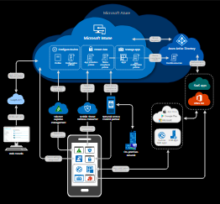

With Intune, you can:  
Choose to be 100% cloud with Intune, or be co-managed with Configuration Manager and Intune.  
Set rules and configure settings on personal and organization-owned devices to access data and networks.  
Deploy and authenticate apps on devices — on-premises and mobile.  
Protect your company information by controlling the way users access and share information.  
Be sure devices and apps are compliant with your security requirements.

1. 32. Question

You are the Microsoft Office 365 administrator for a company. You need to perform security and compliance reviews before new updates are distributed to the entire company. What should you implement?

* +  FastTrack
  +  standard releases
  +  Microsoft 365 Enterprise Test Lab
  +  targeted releases

Unattempted

Set up the Standard or Targeted release options in Office 365:  
With Office 365, you receive new product updates and features as they become available instead of doing costly updates every few years. You can manage how your organization receives these updates. For example, you can sign up for an early release so that your organization receives updates first. You can designate that only certain individuals receive the updates. Or, you can remain on the default release schedule and receive the updates later.  
Standard release  
This is the default option where you and your users receive the latest updates when they’re released broadly to all customers.  
Targeted release  
With this option, you and your users can be the first to see the latest updates and help shape the product by providing early feedback. You can choose to have individuals or the entire organization receive updates early.  
Benefits of Targeted release  
Targeted release allows admins, change managers, or anyone else responsible for Office 365 updates to prepare for the upcoming changes by letting them:  
-Test and validate new updates before they are released to all the users in the organization.  
-Prepare user notification and documentation before updates are released worldwide.  
-Prepare internal help-desk for upcoming changes.  
-Go through compliance and security reviews.  
-Use feature controls, where applicable, to control the release of updates to end users.

1. 33. Question

You are the Miscrosoft 365 administrator for a company. You deploy Windows 10 to all devices using Windows Autopilot. You need to ensure that employees can install Microsoft office 365 ProPlus on their devices. What are two possible ways to achieve this goal ? Each correct answer presents a part of a solution.

* +  Download and install the Office ProPlus Windows Installer (MSI) package
  +  Enable auto-deployment of Office 365 apps for all devices
  +  Use the self-install option on the Office 365 dashboard
  +  Update the Windows AutoPilot deployment profile to include the Office 365 apps.

Unattempted

<https://docs.microsoft.com/en-us/deployoffice/deploy-office-365-proplus-from-a-local-source>  
<https://docs.microsoft.com/en-us/microsoft-365/business/add-autopilot-devices-and-profile>

1. 34. Question

You are the Office 365 administrator for a company. You encounter a problem in your tenant. You launch the Microsoft admin center and select Create a new service request.  
You need to get help resolving your problem through the admin center.  
Which three actions can you perform from the admin center? Each correct answer presents a complete solution

* +  Receive a Microsoft technical support phone number to speak with a Microsoft support technician
  +  Request a Microsoft service technician to contact you by using email
  +  Use the query text box to type information about your problem and receive links to help documentation
  +  Schedule a time for a Microsoft service technician to call you
  +  Chat with a live Microsoft Service engineer

Unattempted

1. 35. Question

You deploy Enterprise Mobility + Security E5 and assign Microsoft 365 licenses to all employees. Employees must not be able to share documents or forward emails that contain sensitive information outside the company.  
You need to enforce the file sharing restrictions. What should you do?

* +  Use Microsoft Azure Information Protection to define a label. Associate the label with an Azure Rights Management template that prevents the sharing of files or emails that are marked with the label.
  +  Create a Microsoft SharePoint Online content type named Sensitivity. Apply the content type to other content types in Microsoft 365. Create a Microsoft Azure Rights Management template that prevents the sharing of any content where the Sensitivity column value is set to Sensitive.
  +  Use Microsoft Azure Information Rights Protection to define a label. Associate the label with an Active Directory Rights Management template that prevents the sharing of files or emails that are marked with the label.
  +  Create a label named Sensitive. Apply a Data Layer Protection policy that notifies users when their document contains personally identifiable information (PII)

Unattempted

1. 36. Question

You have a hybrid environment that includes Microsoft Azure AD. On-premises applications use Active Directory Domain Services (AD DS) for authentication methods to use. You need to determine which authentication methods to use for the following feature?  
Log on to Windows 10 devices that are managed by Microsoft Intune

* +  Azure AD only
  +  AD DS and Azure AD
  +  AD DS only

Unattempted

What is Azure Active Directory?

Azure Active Directory (Azure AD) is Microsoft’s cloud-based identity and access management service, which helps your employees sign in and access resources in:  
External resources, such as Microsoft Office 365, the Azure portal, and thousands of other SaaS applications.  
Internal resources, such as apps on your corporate network and intranet, along with any cloud apps developed by your own organization.  
Who uses Azure AD?  
Azure AD is intended for:  
IT admins. As an IT admin, you can use Azure AD to control access to your apps and your app resources, based on your business requirements. For example, you can use Azure AD to require multi-factor authentication when accessing important organizational resources. Additionally, you can use Azure AD to automate user provisioning between your existing Windows Server AD and your cloud apps, including Office 365. Finally, Azure AD gives you powerful tools to automatically help protect user identities and credentials and to meet your access governance requirements.  
App developers. As an app developer, you can use Azure AD as a standards-based approach for adding single sign-on (SSO) to your app, allowing it to work with a user’s pre-existing credentials. Azure AD also provides APIs that can help you build personalized app experiences using existing organizational data.  
Microsoft 365, Office 365, Azure, or Dynamics CRM Online subscribers. As a subscriber, you’re already using Azure AD. Each Microsoft 365, Office 365, Azure, and Dynamics CRM Online tenant is automatically an Azure AD tenant. You can immediately start to manage access to your integrated cloud apps.

1. 37. Question

You have a hybrid environment that includes Microsoft Azure AD. On-premises applications use Active Directory Domain Services (AD DS) for authentication methods to use. You need to determine which authentication methods to use for the following feature?  
Log on to Windows 10 devices by using Windows Hello

* +  Azure AD only
  +  AD DS only
  +  AD DS and Azure AD

Unattempted

What are the Differences Between Azure Active Directory and Azure Active Directory Domain Services?  
Azure Active Directory Domain Services (AADDS):

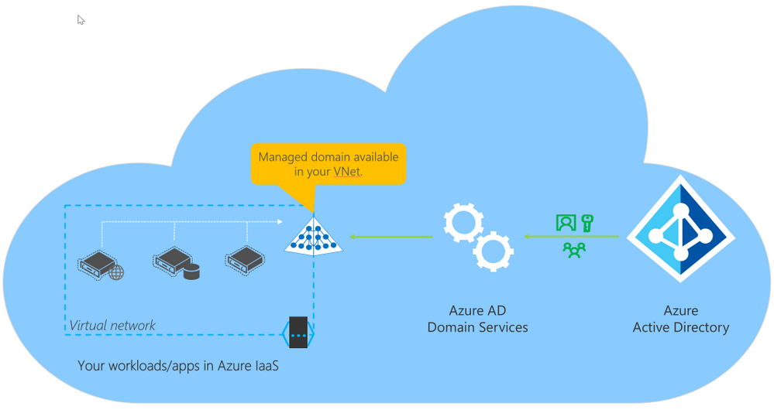

Azure Active Directory Domain Services (Azure AD DS) provides a managed domain services with a subset of fully compatible traditional AD DS features such as domain join, group policy, LDAP, and Kerberos / NTLM authentication.

It integrates with Azure AD and, when synchronized with an on-premises AD DS environment, allows you to extend your on-prem identities to run in Azure as part of a lift-and-shift strategy.

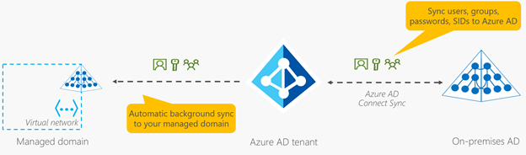

Pros  
The deployment of AADDS is relatively simple once you have your on-prem AD connected to AAD using Ad Connect. It takes away the need for you to deploy your Domain Controllers in Azure and to ensure that your DCs are in different fault and update domains, and it takes care of the DC patching for you.  
AADDS provides an experience that is fully compatible with a subset of features of Active Directory (see above). Depending on your apps, they may keep running in the cloud without any modifications.  
As I mentioned since it’s a managed Directory service, it is highly available the DCs and the AADDS will be automatically backed up.  
You will not need to set up a site-to-site VPN or use ExpressRoute to facilitate the replication of self-managed regular AD domain controllers.

Cons  
AADDS does support Group Policies. However, there is no GPO replication from on-prem; you must recreate the policies you need in the managed directory service. If you change one on-prem, you must perform the same change in the managed Directory.  
AD domain/forest trusts are not supported at this point. (it’s on the roadmap).  
There are no capabilities for Geo-distributed deployments. Your managed AADDS is limited to the virtual network on which you deployed it. You can go around that problem by setting up VPNs and peered virtual networks, but it adds considerably more complexity to your environments.

As you can see in the diagram above, the replication from your Azure AD tenant to AADDS is a one-way replication. There are no facilities for LDAP writebacks outside of the managed domain in that virtual network, which means that the changes are NOT written back to the on-prem AD through the AD Connect sync process.

Active Directory (AD) in IaaS

Deploying Active Directory in IaaS is virtually the same as setting it up in remote offices. You need a connection (site-to-site VPN or ExpressRoute), DCs deployed in each Virtual networks, defined sites in AD to managed replication and authentication requests.

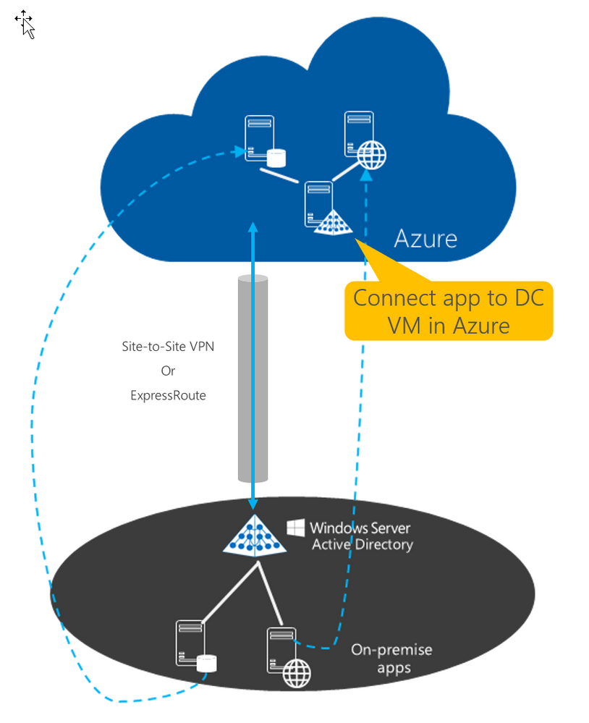  
These are tasks that we all know and have been doing for years. It feels familiar. It’s comfortable and that’s ok. This design also has Pros and Cons.

Pros  
As I mentioned, it’s familiar and comfortable. It ensures that if an app worked on-prem it will still work once migrated to azure, the Application Partitions, the extended schema, the group policies will all be there. Writebacks will occur natively without any duplicate work.

you are not limited to a single virtual network. you can deploy as many sites as required anywhere in the world where Azure regions are found.

Cons  
It’s not a managed Directory Service, therefore you must take care of it. Each additional domain Controller is another machine you must maintain and patch.

You must define where you deploy each DC to ensure availability. You must manage the backup and DR capabilities

Virtual Machines are typically more expensive than managed services (depending on how many Dcs you deploy and the size of the VMs)

Your environment is significantly more complex due to the VPN/ExpressRoutes added VMs and custom DNS service.

1. 38. Question

You have a hybrid environment that includes Microsoft Azure AD. On-premises applications use Active Directory Domain Services (AD DS) for authentication methods to use. You need to determine which authentication methods to use for the following feature?  
Sign in to Outlook on the web by using multi-factor authentication

* +  AD DS only
  +  AD DS and Azure AD
  +  Azure AD only

Unattempted

1. 39. Question

You need to educate stakeholders about how Microsoft 365 component enable effective collaboration. Which of the following tools/service will you use for the following task ?  
A cloud service that enables you to store, organize,add third-party apps, access information from almost any device, allow sharing with external people by default, all by using web-browser.

* +  OneDrive for Business
  +  SharePoint Online
  +  Microsoft Teams
  +  Microsoft Yammer

Unattempted

Yammer is a tool for microblogging and falls under the category “Enterprise Social Media”. Yammer is a form of social media, a social intranet for companies. People can use it to post short messages, to which colleagues (or potentially also invited people from outside of the organisation, like partners, customers or freelancers) can respond.

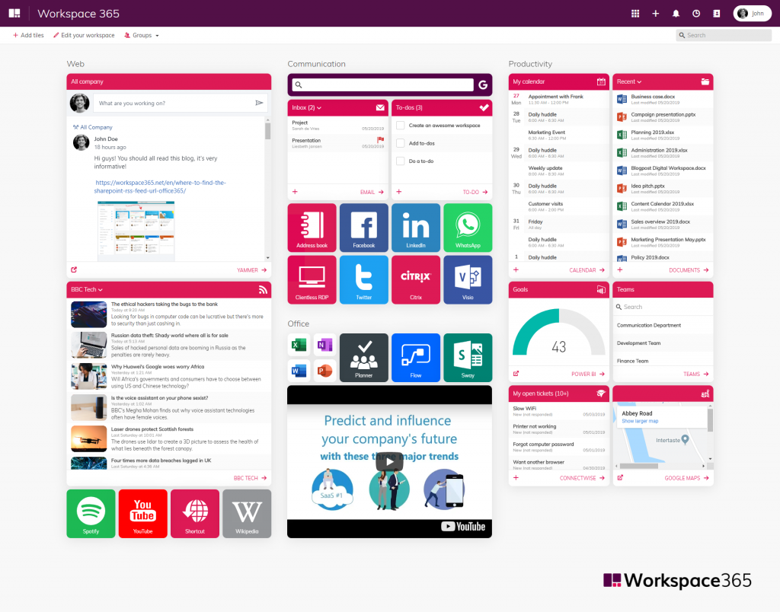  
Increase collaboration within teams, departments and locations  
Yammer simplifies collaboration and communication by making messages visible from people of whom you might not expect are able to help you with your question or challenge. People who are not in the same team or work at the same department can help each other easily through Yammer and everyone can share knowledge at the right moment. With this you connect knowledge and people from different teams, departments, locations or even countries.

What’s the difference between Microsoft Teams and Yammer?  
Teams is software for chatting and Yammer, like mentioned before, is a social intranet.Teams is, like the name says, a good tool for teams: small groups of people who work together closely en because of that need to communicate often and rapidly. It’s very focused with short communication lines.  
Yammer however is focused on the collaboration and communication between larger groups of people, like project groups, departments or entire companies. It’s easy to exchange information on a greater scale and it’s focused on sharing knowledge, creating new and unexpected collaborations and collecting feedback.

1. 40. Question

You need to identify which Microsoft platforms provide hybrid capabilities for migrating from an on-premises deployment. Which two platforms provide hybrid capabilities for migration? Each correct answer provides a complete solution. (Choose two)

* +  Microsoft Yammer
  +  Microsoft Exchange
  +  Microsoft Teams
  +  Microsoft Skype for Business

Unattempted

<https://docs.microsoft.com/en-us/Office365/Enterprise/microsoft-cloud-it-architecture-resources>

1. 41. Question

You need to reduce the amount of time that the IT team spends on user support. What are three possible ways to achieve this goal? Each correct answer presents a complete solution.

* +  Enable Microsoft Office 365 Customer Lockbox
  +  Upgrade all client devices to Windows 10
  +  Deploy Microsoft Office 365 Professional Plus to all client devices
  +  Use Windows AutoPilot to deploy devices
  +  Deploy Microsoft MyAnalytics to devices

Unattempted

Overview of Windows Autopilot  
Windows Autopilot is a collection of technologies used to set up and pre-configure new devices, getting them ready for productive use. You can also use Windows Autopilot to reset, repurpose and recover devices. This solution enables an IT department to achieve the above with little to no infrastructure to manage, with a process that’s easy and simple.  
Windows Autopilot is designed to simplify all parts of the lifecycle of Windows devices, for both IT and end users, from initial deployment through the eventual end of life. Leveraging cloud-based services, it can reduce the overall costs for deploying, managing, and retiring devices by reducing the amount of time that IT needs to spend on these processes and the amount of infrastructure that they need to maintain, while ensuring ease of use for all types of end users. See the following diagram:

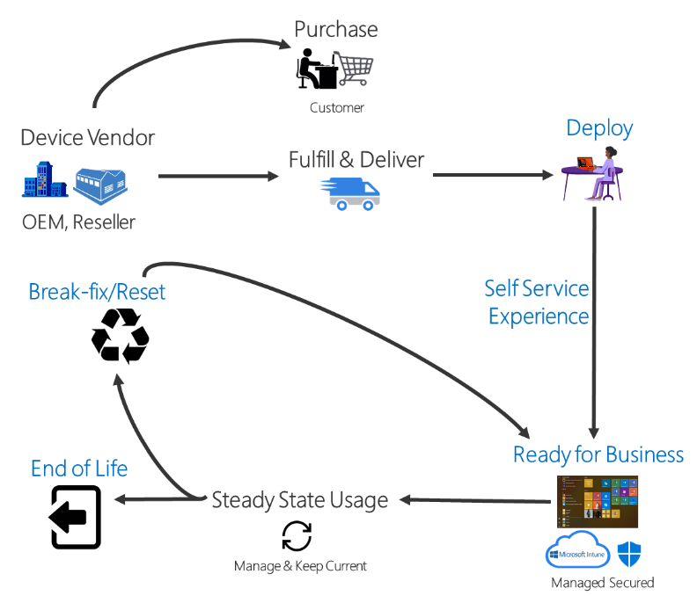

<https://social.technet.microsoft.com/wiki/contents/articles/35748.office-365-what-is-customer-lockbox-and-how-to-enable-it.aspx>

1. 42. Question

You use Microsoft 365 Usage analytics. You need to know the number of users who are active today and were also active last month. Which adoption metric should you use?

* +  CumulativeActiveUsers
  +  EnabledUsers
  +  MoMReturingUsers
  +  ActiveUsers

Unattempted

Adoption Metrics  
Microsoft 365 usage analytics contains additional adoption metrics related to active users to show adoption of the products over time. These metrics are valid for the month, year, and product selected and are defined as follows.

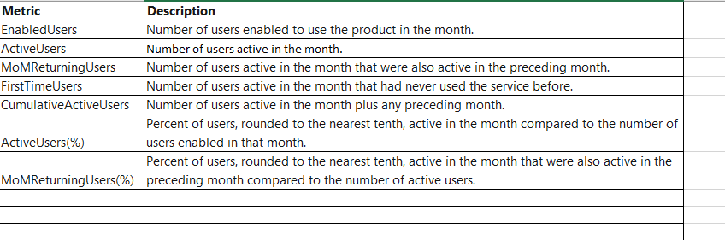

1. 43. Question

You use Microsoft Business Products. When you try to create a support request, you receive the following message:  
You don’t have permission to access this page or perform this action.  
You need to determine the cause of the error message. What is the cause?

* +  Your password is expired
  +  Your account is disabled
  +  Your company does not have Premier support
  +  Your account is not a member of the global admin role

Unattempted

Your subscription comes with a set of admin roles that you can assign to users in your organization. Each admin role maps to common business functions and gives people in your organization permissions to do specific tasks in the admin centers.

1. 44. Question

Your company has a Microsoft Office 365 subscription. You need to co-author files with other users. Which tool should you use?

* +  Microsoft Skype for Business Online
  +  Microsoft Office Delve
  +  Microsoft SharePoint Online
  +  Microsoft Exchange Online

Unattempted

With SharePoint, multiple people can work together on a Word document, Excel spreadsheet, or PowerPoint presentation. When everyone is working at the same time, that’s called co-authoring.  
What do I need to co-author a document?  
Co-authoring is available for documents stored in OneDrive or SharePoint.  
To co-author with others, you need:  
A shared storage area OneDrive, OneDrive for Business, SharePoint Online and SharePoint Server are shared storage areas which enable co-authoring.  
Apps that support co-authoring Word and PowerPoint on all devices and versions more recent than Office 2010 support co-authoring. The Excel mobile apps and the latest version of Excel for Office 365 also support co-authoring.  
A co-authoring friendly document Co-authoring is only supported on modern file formats including: .docx (Word), .pptx (PowerPoint), and .xlsx (Excel).  
Edit permissions for co-authors All co-authors must have permission to access and edit the documents.

1. 45. Question

Your company plans to purchase a Microsoft 365 subscription. The company requires intranet and team sites. You need to select a Microsoft 365 subscription that provides the required features.  
Which two subscription can you use? Each correct answer presents a complete solution.

* +  Office 365 Home
  +  Office Business Premium
  +  Office 365 Business
  +  Office 365 Business Essentials

Unattempted

1. 46. Question

Your company purchases Microsoft 365 Enterprise and Azure AD P2 licenses. You need to provide identity protection against malicious login attempts. What should you implement?

* +  Azure AD Identity Protection
  +  Azure AD Privileged Identity Management
  +  Azure Information Protection
  +  Azure Identity and Access Management

Unattempted

What is Azure Active Directory Identity Protection?  
Identity Protection is a tool that allows organizations to accomplish three key tasks:  
Automate the detection and remediation of identity-based risks.  
Investigate risks using data in the portal.  
Export risk detection data to third-party utilities for further analysis.

1. 47. Question

Your organization is considering subscribing to Microsoft 365. You need to educate stakeholders about how Microsoft 365 component enable effective collaboration. Which of the service will you use for the following task?  
A cloud service that enables you to store and protect files, share files with others, access files for anywhere using an app or a web-browser and restore all files to a previous date and time.

* +  OneDrive for Business
  +  SharePoint Online
  +  Microsoft Teams
  +  Microsoft Yammer

Unattempted

Benefits of Microsoft Office 365 OneDrive:  
Document Sharing- OneDrive’s robust document sharing features provide another key business collaboration benefit. You have several ways to share files with your organization and with external users. Link sharing creates a direct link to the document, which allows internal or external users to access the information.  
You can set the document to require a sign-in, which limits sharing to your internal organization accounts only. If you need to make an external link accessible to an external contributor, but you don’t want to keep that link active forever, the expiration date feature automatically disables the link at a specific time. Your documents can be read-only, which prevents any changes, or you can allow the viewer to make edits.  
Anytime, Anywhere Access to Files – One of the benefits of Microsoft Office 365 OneDrive for Business is that it operates within the cloud, so you don’t have to log in from a particular workstation or device to get access to your files. You also don’t need to be physically in the office or logged into your work network, unless the IT department specifically configured OneDrive with this deployment option.  
Collaborative Office Document Editing – You get through a project much faster when your team all views the same document version. OneDrive for Business integrates with Word, Excel and other applications for streamlined collaboration. You see changes to the document in real-time through the co-authoring feature, as well as a color indicator displaying where your coworkers made changes.  
User-Friendly Interface: You also don’t have a complicated or hard-to-use interface with OneDrive. It’s almost identical to the personal version of OneDrive, so you don’t have much of a learning curve if you already used that product.  
Local File Synchronization-OneDrive allows you to work with your files from anywhere as long as you have an Internet connection, but what if you end up in no signal land? The sync client saves a local copy of your files or folders to your computer, so you have access to important documents offline. Once you reconnect to the Internet, your changes get uploaded to the cloud, and any new additions get downloaded to your computer.  
Security- Your collaboration efforts may involve sensitive data, which often gets put at risk through inadvertent sharing, poor data management practices and other problems. OneDrive for Business incorporates several security features to limit the risk from remote connections and workplace collaboration.  
Encryption at a disk and file level keeps data transmission secure. Network administrations control user access to files, so you only have access to the documents relevant to your position. Additionally, external file sharing or non-domain joined devices may be blocked from accessing files.  
<https://products.office.com/en-za/onedrive-for-business/online-cloud-storage>

1. 48. Question

Your organization is considering subscribing to Microsoft 365. You need to educate stakeholders about how Microsoft 365 component enable effective collaboration. Which tool will you use for following service?  
A cloud service that enables you to store,organize, add third-party apps, access information from almost any device, allow sharing with external people by default, all by using a web-browser.

* +  OneDrive for Business
  +  SharePoint Online
  +  Office 365 ProPlus
  +  Microsoft Teams
  +  Microsoft Yammer

Unattempted

Yammer is a tool for microblogging and falls under the category “Enterprise Social Media”. Yammer is a form of social media, a social intranet for companies. People can use it to post short messages, to which colleagues (or potentially also invited people from outside of the organisation, like partners, customers or freelancers) can respond.

  
Increase collaboration within teams, departments and locations  
Yammer simplifies collaboration and communication by making messages visible from people of whom you might not expect are able to help you with your question or challenge. People who are not in the same team or work at the same department can help each other easily through Yammer and everyone can share knowledge at the right moment. With this you connect knowledge and people from different teams, departments, locations or even countries.

What’s the difference between Microsoft Teams and Yammer?  
Teams is software for chatting and Yammer, like mentioned before, is a social intranet.Teams is, like the name says, a good tool for teams: small groups of people who work together closely en because of that need to communicate often and rapidly. It’s very focused with short communication lines.  
Yammer however is focused on the collaboration and communication between larger groups of people, like project groups, departments or entire companies. It’s easy to exchange information on a greater scale and it’s focused on sharing knowledge, creating new and unexpected collaborations and collecting feedback.

1. 49. Question

Your organization is considering subscribing to Microsoft 365. You need to educate stakeholders about how Microsoft 365 component enable effective  collaboration. Which of the following services will you use for the following task:  
A chat-based workspace that facilitates real-time collaboration and enables members of an organization to have conversations and create work plans.

* +  Office 365 ProPlus
  +  Microsoft Yammer
  +  OneDrive for Business
  +  SharePoint Online
  +  Microsoft teams

Unattempted

Advantages of Microsoft Teams  
Access to Communication Tools: When you enable Microsoft Teams on Office 365, you and your company have access to a streamlined communication interface to aid in your collaboration. The chat function on Microsoft Teams allows you to have threaded conversations, helping you store brainstorming sessions, conference calls, and other meetings into one, easy to find place.  
Increased Productivity and Collaboration: When you use Microsoft Teams to facilitate your projects, you increase your company’s productivity and collaboration. When you use traditional email to work on a project, you may lose crucial information in threads and certain people may lose out on key points because someone forgot to hit “Reply All.” With Microsoft Team’s chat-based platform, everyone receives the same message at the same time. As a result, people can collaborate and keep the discussion flowing, helping you reach solutions faster and develop more efficient action plans.  
Integration of Other Office 365 Applications: The beauty of Microsoft Teams is that the application does not just limit you to the chat or communication functionality – you can bring any Office 365 application into the mix to increase your team’s productivity. You can all view the same Word document, Excel spreadsheet, PowerPoint presentation, or OneNote document as you communicate around the content.  
<https://products.office.com/en-us/microsoft-teams/group-chat-software>

1. 50. Question

Your organization plans to deploy a subscription -based licensing model of Microsoft Office to devices.  
You must use group policy to enforce Office application settings. You need to deploy Office to the enterprise. Which version of Office should you deploy?

* +  Office 365 ProPlus
  +  Office Professional Plus 2016
  +  Office Online
  +  Office Home and Business 2016

Unattempted

1. 51. Question

Your organization plans to deploy Microsoft 365 in a hybrid scenario. You need to ensure that employees can use a smart card for authentication. Which hybrid identity solution should you implement?

* +  password harsh synchronization with single-on
  +  PingFederate and federation integration
  +  pass-through authentication and single sign-on
  +  Active Directory Federation Services (AD FS)

Unattempted